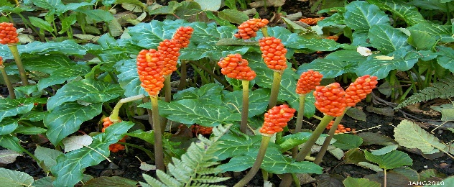
The Berries are Coming! Italian Arum is INVASIVE, TOXIC, AND DIFFICULT TO CONTROL
Italian Arum is a sneaky and creepy little plant, and it lives in abundance on Lopez Island. Italian Arum has beautiful, red and yellow tropical looking blooms in July and August, is green in the winter when everything else is dormant and brown, it is drought tolerant, deer resistant, and has a will to survive like no other. It also destroys sensitive habitat and threatens to displace native plants on our public lands and in our gardens.
Lopez Island neighbors, Jim and Birte Falconer, have partnered with Friends of the San Juans to begin an education, identification, containment, and eradication effort of Italian Arum on our Island. The goal is to create a community model for others to use as we all battle this threat to land, humans, and livestock.
We invite you to complete the following questionnaire to help identify Italian Arum on your property and develop a plan for containment and eradication.
Name: ______________________________________________________________________
Address: ____________________________________________________________________
Contact Information:
Telephone: Land line __________________________Mobile_________________________
Email: _____________________________________________________________________
1) Do you have an infestation of Italian Arum on your property?
YES___________________ NO______________
2) If YES how large is your infestation measured in inches or feet: ______________
3) Are you interested in hosting an Arum eradication and Field Study event?
YES___________________ NO______________
4) Are you interested in helping with an Arum eradication and Field Study event?
YES___________________ NO______________
5) Do you live in a HOA community? If you do, would you consider being a Block Watch
Volunteer to help your neighbors identify Italian Arum and report it to the project leader,
Dixie Budke?
YES___________________ NO______________

